Producer Toolbox - Enhanced Direct Enrollment
Submit Application for On Exchange ACA Plans

Overview

Introduction The purpose of this document is to provide instructions to Brokers for submitting applications on behalf of their clients for on exchange ACA plans within the FFM states. The tasks and steps listed below are in sequential order.

Background Brokers and their clients can enroll, renew, or update their Anthem ACA (on-exchange) plan information, all on one site. No longer required to go to Healthcare.gov to complete these transactions.

Prerequisite A quote has been generated for an Anthem ACA (on exchange) plan by a broker for a client who resides in one of the FFM states.

Steps Step through the tasks listed below to see how to access Broker Portal and submit an Anthem ACA application for an on exchange plan.

Note: only available for FFM states

Task 1: Log in to Producer Toolbox.

Step | Action
1 | Log in to the Broker Portal/ Producer Toolbox.  Note: If you have not signed up then click the Register now link.  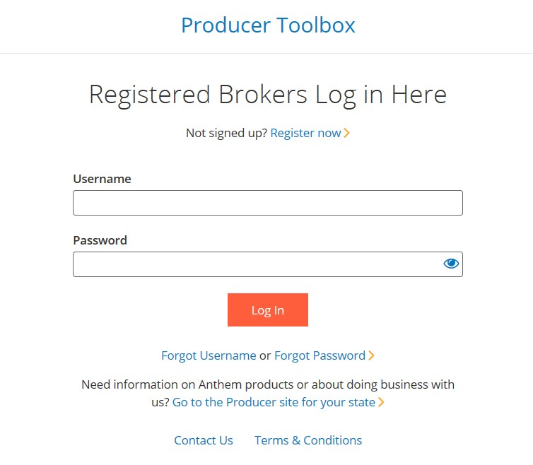

Task 2: Create a Quote.

Step | Action
1 | Select the Start a New Quote button.  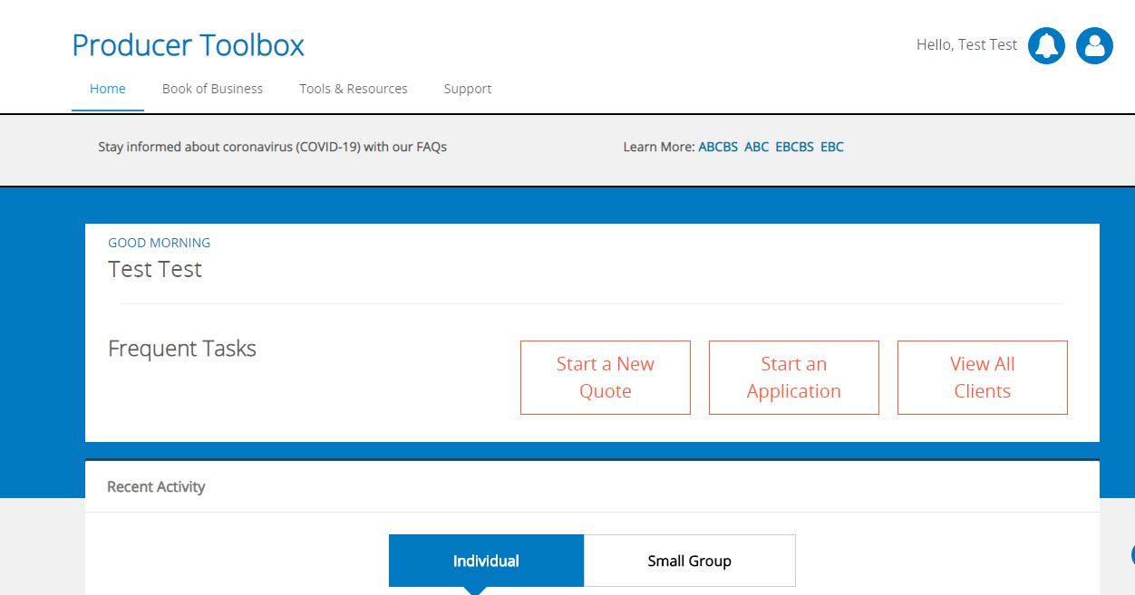  Select Individual Market, select an FFM state, select applicable agent information and select Create Quote.
2 | Enter applicable demographic information for the client as well as income information to estimate subsidy  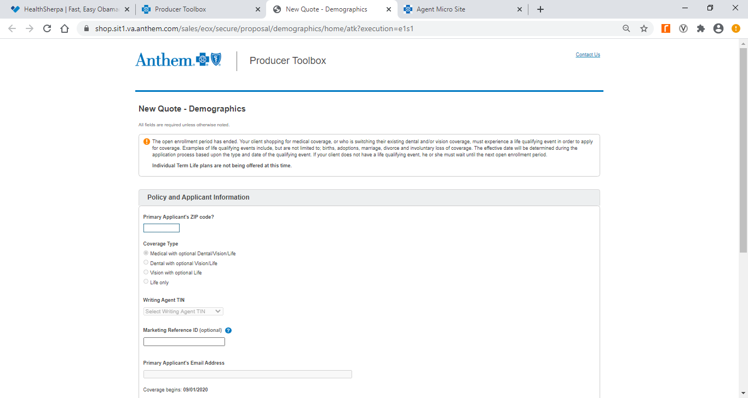.  Note: must enter the valid email address for your client. Each new application must have a different unique email address.

Task 3: Initiate on exchange application.
Step | Action
1 | Select the Apply Now button for an on exchange plan.  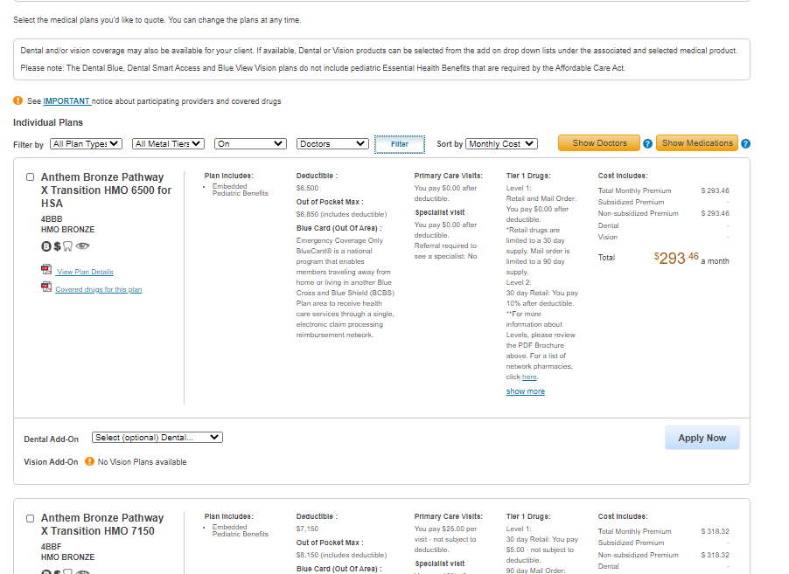
2 | Select Apply on Marketplace button.  Note: You will be required to complete a one-time user registration along with identify proofing for security purposes during the first application.

Task 4: Complete and submit application.
Step | Action
1 | Select to search for an existing application. If no results found, select Create New Application.  Note: You must check the box “I’ve received permission from this consumer to work on their behalf” to search and continue.
2 | Read the Privacy and the use of your information statement to your client and obtain their agreement.
3 | Read each of the questions within the application to the client and enter the answers provided.
4 | After completing all of the questions, review the information for accuracy. Select Edit to correct any of the information within the applicable category.
5 | Read the attestation and agreements to the client and select the response for each statement. Enter the name of the applicant in the signature section.
6 | We will request eligibility results from Healthcare.gov.  Once we have received the results from Healthcare.gov, download the eligibility letter and review the results with the client. Select Continue to finish the application.
7 | Select Manage Application at bottom of the screen to upload any of the required documents and make initial premium payment.
8 | Select Verify to upload the required document. Select Pay to submit initial premium payment.  NOTE: If you do not have the proof documentation at the time of submitting the application, you will not have the ability to upload it later on behalf of your client. Your client will receive an email confirming the submission of the application along with instructions on how to access their dashboard to upload the required documentation and/or make initial premium payment.

Anthem Blue Cross and Blue Shield is the trade name of: In Colorado: Rocky Mountain Hospital and Medical Service, Inc. HMO products underwritten by HMO Colorado, Inc. In Connecticut: Anthem Health Plans, Inc. In Georgia: Blue Cross Blue Shield Healthcare Plan of Georgia, Inc. In Indiana: Anthem Insurance Companies, Inc. In Kentucky: Anthem Health Plans of Kentucky, Inc. In Maine: Anthem Health Plans of Maine, Inc. In Missouri (excluding 30 counties in the Kansas City area): RightCHOICE® Managed Care, Inc. (RIT), Healthy Alliance® Life Insurance Company (HALIC), and HMO Missouri, Inc. RIT and certain affiliates administer non-HMO benefits underwritten by HALIC and HMO benefits underwritten by HMO Missouri, Inc. RIT and certain affiliates only provide administrative services for self-funded plans and do not underwrite benefits. In Nevada: Rocky Mountain Hospital and Medical Service, Inc. HMO products underwritten by HMO Colorado, Inc., dba HMO Nevada. In New Hampshire: Anthem Health Plans of New Hampshire, Inc. HMO plans are administered by Anthem Health Plans of New Hampshire, Inc. and underwritten by Matthew Thornton Health Plan, Inc. In Ohio: Community Insurance Company. In Virginia: Anthem Health Plans of Virginia, Inc. trades as Anthem Blue Cross and Blue Shield in Virginia, and its service area is all of Virginia except for the City of Fairfax, the Town of Vienna, and the area east of State Route 123. In Wisconsin: Blue Cross Blue Shield of Wisconsin (BCBSWI), underwrites or administers PPO and indemnity policies and underwrites the out of network benefits in POS policies offered by Compcare Health Services Insurance Corporation (Compcare) or Wisconsin Collaborative Insurance Corporation (WCIC). Compcare underwrites or administers HMO or POS policies; WCIC underwrites or administers Well Priority HMO or POS policies. Independent licensees of the Blue Cross and Blue Shield Association. Anthem is a registered trademark of Anthem Insurance Companies, Inc.

